AI-Based Student Ride Matching System
A full-stack platform that helps verified college students find other students travelling on similar routes at similar times, and use AI/ML to rank the most suitable travel partners based on route similarity, time, transport mode, detour and estimated cost savings.

What problem are you solving?
Imagine:
Student A lives in Koramangala and travels to college at 8 AM.
Student B lives near HSR and travels to the same college at 8:15 AM.
Their routes overlap significantly.
Both are taking separate autos/cabs.
The system identifies that they are potentially good travel partners.

Instead of simply saying:
"These two students have similar routes."

the system will say:
Match Score: 87%
Route overlap: High
Time difference: 10 min
Detour: Low
Transport: Cab
Estimated saving: ₹120/person
How the complete system works?
Step 1: Student registers
Student creates an account with:
Name, College email/ID, Phone number, Home/start location,
Preferred transport and Other relevant preferences
(The college identity will be verified through college email/ID.)

Step 2: Student creates a trip
For example:
From: HSR Layout
To: College
Date: Monday
Departure: 8:00 AM
Mode: Auto/Cab
(This trip is stored in the database.)

Step 3: System searches for potential matches
The system looks at other students' trips.
It compares:
Starting location
Destination
Route
Departure time
Transport mode
Detour distance
Estimated cost

Step 4: Matching algorithm calculates compatibility.
For example:
Factor Weight
Route overlap 40%
Time compatibility 20%
Detour distance 15%
Transport compatibility 10%
Cost savings 15%

Step 5: AI/ML ranks matches
Suppose five students are potential matches.
The system doesn't just display them randomly.
It ranks:
Student B → 91%
Student C → 84%
Student D → 76%
Student E → 64%
Student F → 52%
The student can then choose whom to connect with.

Step 6: Students connect
After accepting a match, they can:
View basic trip information
Communicate
Coordinate pickup
Confirm ride

Step 7: Trip history
After the trip:
Trip is recorded
Match can be recorded
Cost savings can be estimated
Travel history can be maintained
(This data can potentially help improve future recommendations.)

Where exactly is the "AI" in your project?
The AI/ML component is responsible for ranking potential travel partners based on multiple features such as route overlap, time difference, detour distance, transport compatibility and estimated cost savings

what ML algorithm will you use?
Initial version:
Weighted scoring / recommendation algorithm

Future version:
Machine Learning ranking/recommendation model
KNN for similarity
Logistic Regression
Decision Tree

Functional Requirements
What the system should do:
- User Registration & Login – Students can create accounts and log in.
- Student Verification – Verify users as college students.
- Profile Management – Students can manage their basic details and travel preferences.
- Trip Creation – Students can enter source, destination, date, time and transport mode.
- Ride Matching – System finds students with similar routes and timings.
- AI-Based Recommendation – System ranks potential matches based on route, time, detour, transport and cost.
- Match Acceptance/Rejection – Students can accept or reject suggested matches.
- Communication – Matched students can communicate.
- Trip History – Students can view previous trips and estimated savings.
- Admin Management – Admin can manage users and reports.
- Non-Functional Requirements

How well the system should work:
- Security – Protect user accounts and personal information.
- Privacy – Protect students' location and travel details.
- Performance – Match results should be generated quickly.
- Reliability – System should work consistently with minimal failures.
- Scalability – Should support an increasing number of students and trips.
- Usability – Interface should be simple and easy to use.
- Maintainability – System should be easy to update and modify.
- Availability – System should be accessible whenever students need it.

What is your tech stack?
- Frontend - React.js.
- Backend - Node.js with Express.js.
- Database - Supabase
- AI/ML recommendation component - Python and Scikit-learn.
- Route and distance information - mapping and routing API.
- Version control – GitHub
- Real-time communication - Socket.IO (Future)

Expected Outcome :
Help students find suitable travel partners.
Use AI/ML to rank the best matches.
Help students reduce their travel expenses through ride sharing.
Reduce unnecessary duplicate journeys.
Provide a safe, verified platform for student-to-student ride matching.
Allow students to create trips, connect, communicate and view travel history.

Use Case Diagram :
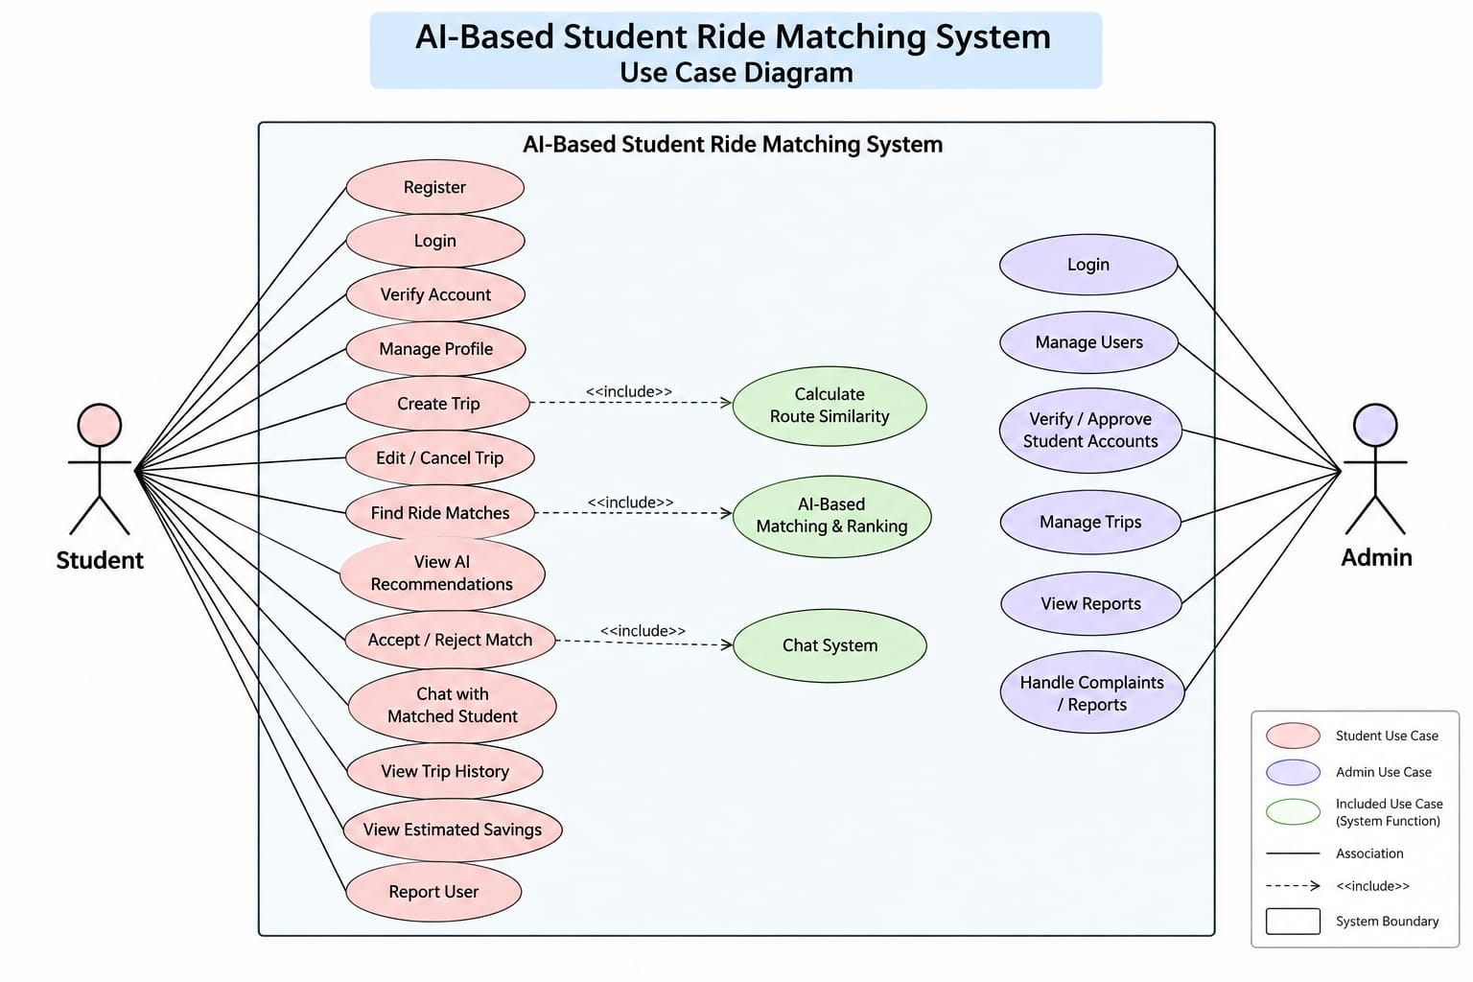

Roadmap :

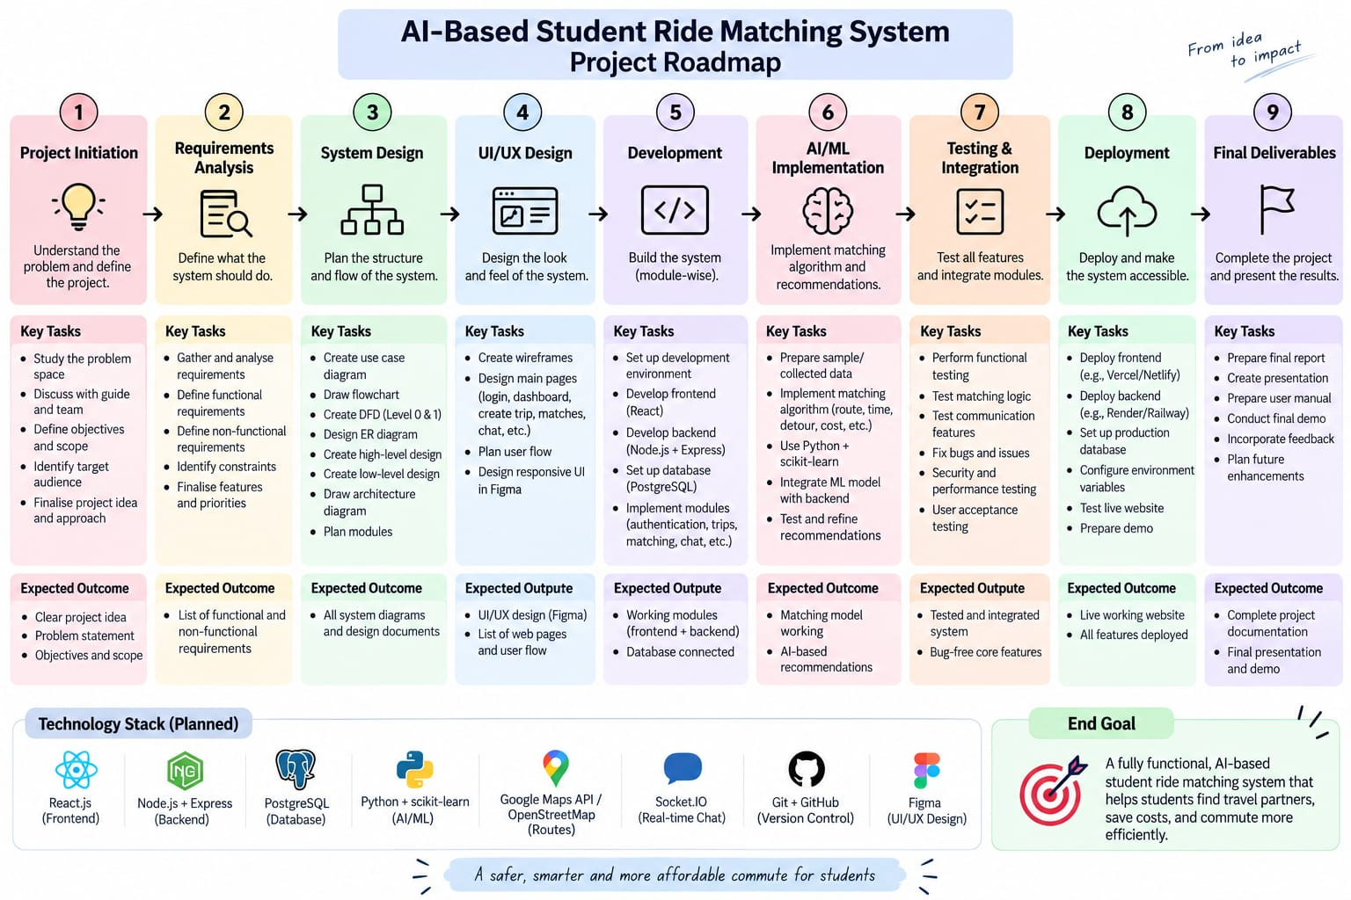s

